**Will Thacher, SULI 2019, December 5th, 2019**

**Multiphysics Model of an Electrochemical Hydrogen Compressor**

**Abstract**

The electrochemical hydrogen compressor (EHC) is a technology that has the potential to play an important role in the hydrogen economy.1 The EHC utilizes a proton exchange membrane (PEM) and electrical power to pressurize hydrogen, which can then be used for applications such as fuel cells. It has several advantages over traditional mechanical compressors: lower costs, higher efficiency, and purer produced hydrogen. $^{1}$ Performance of the EHC is dictated by complex interactions between water management, multiphase transport, and material properties of cell layers. The EHC has been studied experimentally $^{3,4,5}$, but there is a need for a sophisticated mathematical model that can be used to examine cell performance in higher detail in order to make suggestions for optimal cell design. The model is two-dimensional and steady-state. This report describes the mathematical model and suggests an optimal catalyst layer design.

## 1 Introduction

Hydrogen is a promising alternative to fossil fuels that has the potential to cut global emissions on a large scale. One of several barriers to the adoption of hydrogen as a fuel source is its low volumetric energy density. Hydrogen gas must be compressed prior to storage and use, and traditionally this has been accomplished with various mechanical compressors such as pistons.1 Making this compression process cheaper and more efficient will aid in making hydrogen cost-competitive with fossil fuels. The electrochemical hydrogen compressor (EHC) has the potential to achieve lower costs, higher efficiency, and purer produced hydrogen than traditional compressors.2

The EHC has been studied experimentally, but there is a need for a sophisticated mathematical model that can be used to examine cell performance in higher detail in order to make suggestions for optimal cell design. The introductory section of this report describes the EHC device and a specific performance measurement, the polarization curve. The mathematical model is detailed in Section 2 and Appendices A and B. Section 3 focuses specifically on the anode catalyst layer and suggests an optimal design using multiple catalyst layers.

### Operating Principles

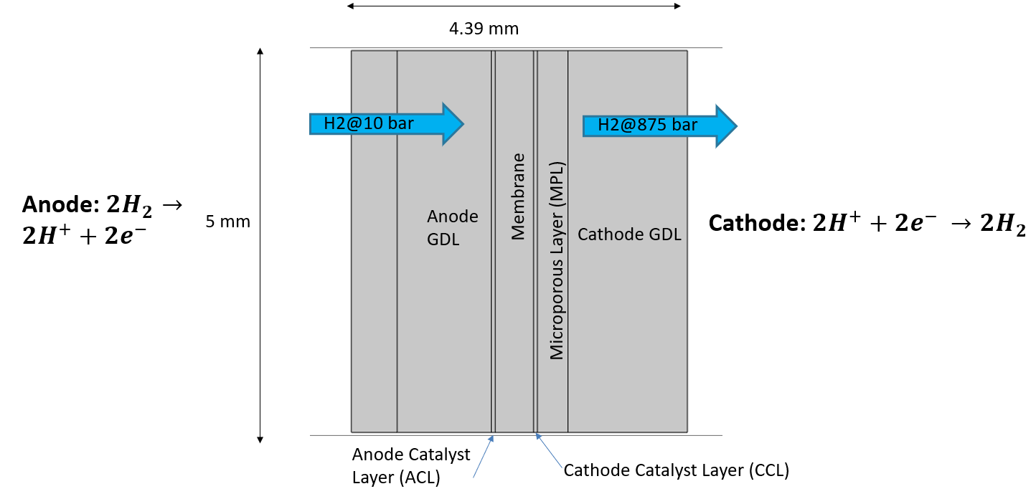

Figure 1: EHC Modeling Domain

The EHC uses electrical power to transport hydrogen from a region of low pressure to a region of high pressure. This is accomplished by oxidizing and reducing hydrogen at the anode and cathode, respectively, and forcing ionized hydrogen through a proton exchange membrane (PEM) by applying a potential difference to the cell. Humidified hydrogen enters the cell through the anode side and diffuses toward the membrane electrode assembly (MEA, containing catalyst layers and membrane) through the gas diffusion layer (GDL). The hydrogen is oxidized in a reaction with a platinum catalyst in the anode catalyst layer (ACL), and the protons are transported across the conductive membrane. Electrons are conducted away from the reaction sites by a carbon mesh to a current collector. Protons recombine with electrons at the cathode catalyst layer (CCL) and reform hydrogen gas in a pressurized environment.

### Polarization curves

This subsection briefly explains the concept of a polarization curve, a measure of cell performance which will be used later in the report. Fig. 2 shows an example of a polarization curve with a voltage breakdown. This graph is showing how much energy (voltage) is required to compress hydrogen at a certain rate (current density). The slope of this line can be thought of as a cell resistance (V=IR). Better performance is indicated by a flatter slope. The mathematical model allows one to easily change a certain parameter or operating condition and compare the resulting polarization curves.

The colors represent voltage losses in the three cell layers: cathode catalyst layer (CCL), anode catalyst layer (ACL) and membrane (Ohmic). This breakdown allows one to separate the contribution of kinetics and layer resistance to the overall cell voltage. For example, Fig. 2 shows that there is a current-independent voltage loss in the cathode catalyst layer and a voltage loss that scales with current in the other layers.

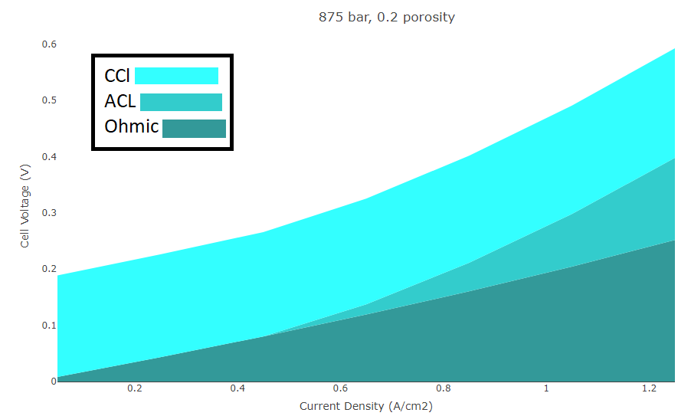

Figure 2: Polarization curve with voltage breakdown. Cell conditions: 875 bar cathode pressure, 0.2 anode catalyst layer porosity, 35 C.

## 2 EHC Mathematical Model

This section provides an outline of the governing transport and kinetics equations for the model. Section 2A covers the porous domain, which includes all layers except the membrane, Section 2B describes the model of membrane transport, and Section 2C covers the catalyst layer model. Appendix A describes in detail how terms in the equations are calculated. Appendix B summarizes the computational method and source terms in different cell layers.

### Porous Domain

The porous domain includes the gas diffusion layers, microporous layer, and catalyst layers. Porous media is comprised of a solid matrix and a void space through which fluids can travel. Transport of the gas mixture (hydrogen gas and water vapor) and liquid water are driven by concentration and pressure gradients through the GDL to the MEA. Darcy’s Law (Eq. 1) relates a pressure gradient to the velocity of a fluid in phase $i$ in porous media. In this model the two phases are mixed water vapor-hydrogen gas and liquid water.

$u_{i}=-\frac{k_{r,i}k_{0}}{η_{i}}∇p_{i}$ (1)

where $k_{r,i}$ is the relative permeability, $k_{0}$ is the absolute permeability, $η_{i}$ is the viscosity,and $p_{G}$ is the pressure.Conservation gives:

$R_{D,i}=∇⋅[ρ_{i}u_{i}]$ (2)

where $R_{i}$ is the production rate of species $i$ and $ρ_{i}$ is the density of species $i$.

Gas transport in the porous domain is also driven by diffusion:

$R_{MS,i}=∇⋅J_{i}+ρ_{G}u_{G}⋅∇ω_{i}$ (3)

$J_{i}=-ρ_{g}ω_{i}\sum_{k}{‍}{\tilde{D}}_{ik}(∇x_{k}-ω_{k})∇p_{G}$ (4)

where $J_{i}$ is the diffusive flux, $ω_{i}$ is the mass fraction, $ρ_{G}$ is the gas mixture density, $x_{k}$ is the mole fraction of species k, and ${\tilde{D}}_{ik}$ is the inverted Maxwell-Stefan Diffusion coefficient.

Electron transport follows Ohm’s Law:

$j_{ }=∇⋅[-σ_{e}^{eff}∇ϕ_{e}]$ (5)

where $j_{ }$ is the electronic current density, $ϕ_{e}$ is the electronic potential, and $σ_{e}^{eff}$ is the effective electronic conductivity. Heat transport is described by a conduction equation:

|  |  |
| --- | --- |
| $∇⋅\left[-k_{T}^{eff}∇T\right]=Q_{gen}$ | (6) |

where $Q_{gen}$ is the heat generated, T is the temperature, and $k_{T}^{eff}$ is the thermal conductivity, which differs by layer. Reaction kinetics are described by a Butler-Volmer equation:

|  |  |
| --- | --- |
| $$i_{rxn}=A {S_{G}i}_{0}\left[\frac{c_{o}}{c_{o}^{ref}}\exp\left(\frac{α_{a}F}{RT}η\right)-\frac{c_{r}}{c_{r}^{ref}}\exp\left(-\frac{α_{c}F}{RT}η\right)\right]$$ | (7) |

where *A* is the electrochemically active surface area, $i_{0}$ is the exchange current density, ${ c}_{o}$ is the concentration of the oxidized species, $c_{r}$ is the concentration of the reduced species, $c_{o,r}^{ref}$ is the reference concentration, $α_{a,c}$ are the charge transfer coefficients for the anode (oxidation) and cathode (reduction) reactions, and $η$ is the overpotential. *F* and *R* are Faraday’s constant and the universal gas constant respectively.

### Membrane Transport

The membrane in the EHC is a polymer-electrolyte membrane similar to Nafion. The membrane is composed of a fluorocarbon chain with negatively charged sulfonic acid groups attached. When hydrated, these sulfonic acid groups form conductive pathways for cations. The model draws on the work of Weber and Newman (2003, 2004) for a physical and mathematical model of membrane transport $. ^{7,8}$ Essentially there are two possible modes of proton transport corresponding to a membrane that is equilibrated with water vapor or liquid water, each with different properties. In the liquid-equilibrated mode, water-filled channels form between inverted micelles, and protons drag water molecules through these channels in a process called electroosmotic drag (EOD). The EOD coefficient $ξ$ quantifies how many water molecules are pulled across by each proton. In the vapor-equilibrated mode, a proton and a water molecule form a hydronium ion which diffuses between inverted micelles.

Proton transport occurs in parallel between these two modes, with $S_{m}$ representing the fraction of the membrane that is equilibrated with liquid water. For a more detailed description of membrane transport see references 6 and 7. Proton transport is described by the following equation:

$j_{rxn,m}=∇⋅[(1-S_{m})(-k_{m,v}^{eff}∇ϕ_{m})-\frac{k_{m,v}^{eff}ξ_{m,v}^{eff}}{F}∇μ_{w})+S_{m}(-k_{m,l}^{eff}∇ϕ_{m}- \frac{-k_{m,l}^{eff}ξ_{m,l}^{eff}}{F})∇μ_{w})]$ (8)

Similarly, water transport in the membrane is described by:

$$R_{w,m}=∇⋅[(1-S_{m})((\frac{-k_{m,v}^{eff}ξ_{m,v}^{eff}}{F}∇ϕ_{m})-(α_{m,v}^{eff}+\frac{-k_{m,v}^{eff}(ξ_{m,v}^{eff})^{2}}{F^{2}})∇μ_{w})+$$

$S_{m}((\frac{-k_{m,l}^{eff}ξ_{m,l}^{eff}}{F}∇ϕ_{m})-(α_{m,l}^{eff}+\frac{-k_{m,l}^{eff}(ξ_{m,l}^{eff})^{2}}{F^{2}})∇μ_{w})]$ (9)

where $k_{m,i}^{eff}$ is the protonic conductivity of the ionomer for water in transport phase $i$, $ξ_{m,i}^{eff}$ is the electroosmotic coefficient for water in phase $i$. $ϕ_{m}$ is the protonic potential and $μ_{w}$ is the chemical potential of water in the membrane. $α_{m,i}^{eff}$ is the transport coefficient, a value that quantifies how water in a certain phase moves in response to a chemical potential gradient in the absence of electric fields or electroosmotic drag. $j_{rxn,m}$ is the current density of the reaction.

Water can move into and out of the membrane from the liquid and vapor phase, driven by concentration and pressure gradients, which are both captured in the chemical potential μ.

$R_{m,v}=[μ_{w}-μ_{v}]k_{m,v}$ (10)

$R_{m,L}=[μ_{w}-μ_{L}]k_{m,L}$ (11)

$R_{w,m}=-(R_{m,v}+R_{m,L})$ (12)

where $k_{m,i}$ is the membrane water desorption coefficient for phase $i$, $μ_{v}$ is the chemical potential of water vapor in the porous domain, and $μ_{L}$ is the chemical potential of liquid water in the porous domain. This desorption of water in and out of the membrane due to diffusion can be thought of as an attempt to balance water distribution in the MEA. As shown in Fig. 3, water distribution in the MEA is a competition between forces. The anode side is at much lower pressure than the cathode side, so pressure drives water back toward the anode. This movement of water is counter to protonic flow, and in effect, it increases the resistance of the membrane.

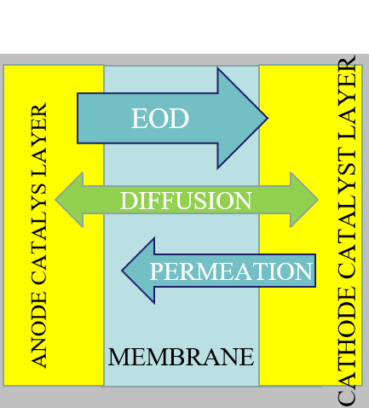

Figure 3: Forces driving water distribution in the MEA. EOD drags water along with protonic current, permeation driven by pressure pushes water from cathode to anode, and diffusion-driven movement attempts to balance water distribution in the MEA. Figure not to scale.

In addition to driving water back to the anode, the cathode pressure can also drive hydrogen back toward the anode. This means that hydrogen has to re-cross the membrane upon reaching the anode catalyst layer, reducing cell efficiency.

${R_{m,H2 } = k}_{H2}(p_{H2}-p_{H2,m})$ (13)

Where $R_{m,H2 }$ is the rate of hydrogen dissolution into the membrane, $k_{H2}$ is the membrane permeation coefficient, and $p_{H2}$ is the pressure of hydrogen in the porous domain. $p_{H2,m}$ represents the concentration of hydrogen ions in the membrane as a pressure.

### Catalyst Layer Model

The catalyst layer is composed of carbon-supported platinum particles and a proton-conducting ionomer (such as Nafion). The composition of the CL must obey the following equality:

$1= \frac{V_{ionomer}+V_{solid}+V_{void}}{V_{total}}$ (14)

Where *V* is the volume of each component. The porosity represents the void space that is not occupied by the ionomer and the solid (carbon). Increasing the amount of ionomer increases the protonic conductivity, and increasing the solid increases the electronic conductivity. The equation for protonic conductivity is drawn from the model of Li, Das, and Liu (2010).10 This model assumes an idealized spherical agglomerate with platinum, carbon, ionomer and void space in concentric rings. Using geometric arguments, the following equation for conductivity was obtained:

$σ_{m}^{eff} = σ_{m}- \frac{3(1-ε_{m})σ_{m}}{3-ε_{m}} - \frac{3ε_{v}(σ_{m}-\frac{3(1-ε_{m})σ_{m}}{3-ε_{m}})}{2+ε_{v}}$ (15)

Where $σ_{m}$ is the bulk protonic conductivity of the ionomer and $ε_{m}$ and $ε_{v}$ are the volume fractions of the ionomer and void space, respectively.

## 3 Results and Discussion: Multiple Catalyst Layers

The mathematical model has been used to conduct a full sensitivity analysis to material properties and operating conditions which is detailed in another report.12 This report found that the conductivity of the membrane is the most important material property for cell performance. The model showed that at high-pressure operation, the cathode side of the cell dries out due to high permeation. The performance was more sensitive to the properties of the anode catalyst layer than the cathode catalyst layer. Thus, an optimal anode catalyst layer design is suggested and analyzed in this section.

### Effect of Catalyst Layer on Cell Performance

The catalyst layer (CL) affects cell performance in several ways. Eq. 7, which describes the reaction kinetics, must be equal to the electronic current density (Eq. 5), as electrons are created when hydrogen is split into protons and electrons in the CL. The carbon matrix that makes up the GDL is very conductive, so there is little voltage loss in these layers. The cathode side of the cell is grounded, so the voltage value seen on the polarization curve represents electronic potential on the anode side of the cell. This potential is determined primarily by the reaction kinetics and the conductivity of the membrane.

Eq. 7 shows how the reaction affects electronic potential. Overpotential *η* is defined in Appendix A, Eq. 14 as the difference between electronic and protonic potential. In order to satisfy the equality of Eq. 5 and 7, *η* may be higher or lower depending on the other terms in Eq. 7. For example, with higher temperature or reactant concentration, *η* can be lower and still satisfy the equality. If all other terms are fixed, a higher protonic potential will cause a higher electronic potential. If protonic potential is fixed, then a lower reactant concentration, lower saturation or lower temperature will also cause a higher electronic potential. Physically this means that a higher potential (more energy) will have to be applied to the cell in order to create a certain current density. This electronic conductivity can be minimized mathematically by increasing saturation, reactant concentration, and protonic conductivity. These are interrelated factors that must be balanced, which leads to the idea of having a gradient of catalyst layer properties.

### Effect of Multiple Anode Catalyst Layers

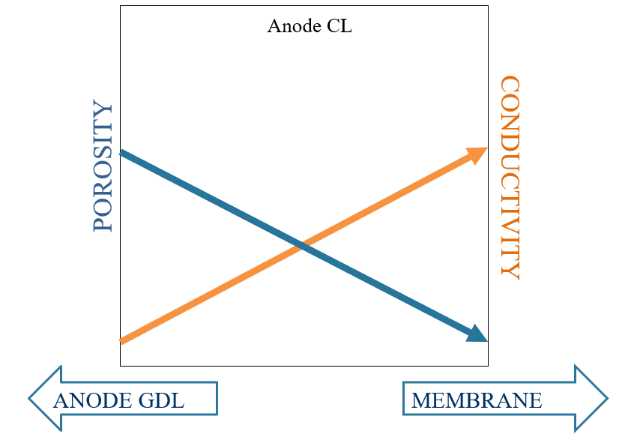

Figure 4: Idealized anode catalyst layer properties. This gradient in properties moving toward the membrane can be approximated by having two CLs.

Eq. 14 says that the composition of the catalyst layer is a tradeoff between porosity, ionomer, and solid. The CL composition affects terms in Eq. 7. Higher porosity will result in higher reactant concentration, and higher ionomer content will result in increased conductivity. Saturation is affected by the amount of liquid water in the CL. Water vapor is consumed in the reaction through EOD, so the reaction profile in the layer will have an impact on the water profile and vice versa.

In a single catalyst layer of uniform porosity and conductivity, the reaction will be concentrated at the membrane interface at steady-state in order to reduce ohmic losses. It is energetically easier for protons to travel a short distance to the membrane. However, this means that the CL will be mostly underutilized (see Fig. 5)

The idea of having multiple CLs is that these tradeoffs can be balanced to maximize ease of reaction. The leftmost part of the catalyst layer should have higher porosity to allow a high amount of reactant to enter the layer. As reactant is consumed moving toward the membrane, the porosity can be lower in favor of higher conductivity, which allows protons to easily transport to the membrane. (see Fig. 4) This will create a more even reaction profile, as shown in Fig. 5.

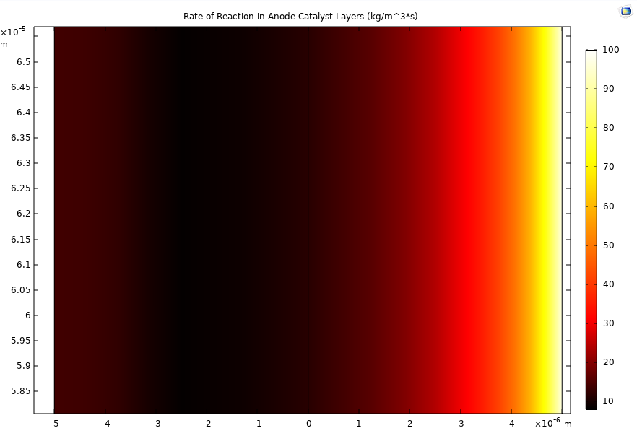

Membrane

Anode GDL

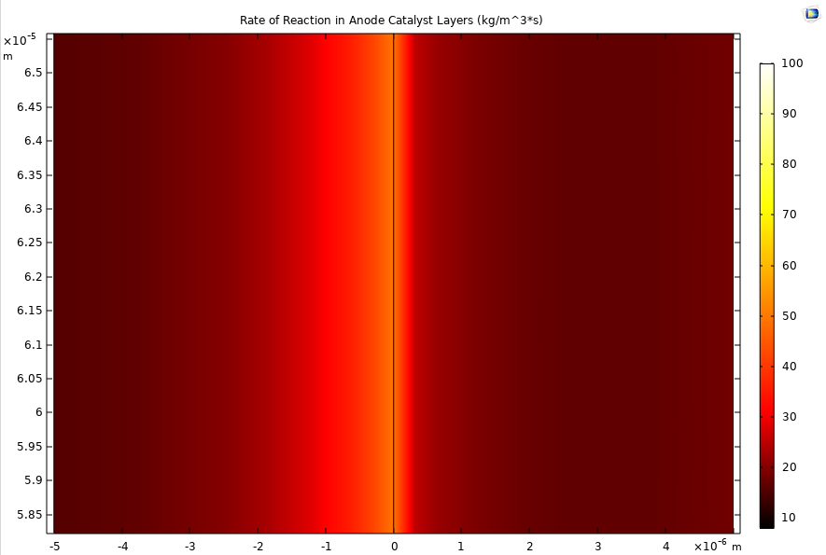

Membrane

Anode GDL

Figure 5: Reaction rate in anode catalyst layers. **Top**: 1 uniform catalyst layer of 10 micron thickness, 18% ionomer, 40% porosity. **Bottom**: 2 catalyst layers of 5 micron thickness each. Left CL: 50% porosity, 20% ionomer. Right CL: 10% porosity, 80% ionomer.

The optimal design was found by running a parameter sweep on a one-dimensional model with many different combinations of ionomer volume and void volume, and then scaling up the design to a two-dimensional model.

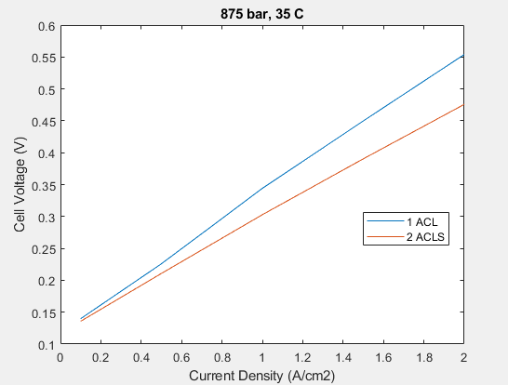

Figure 6: Polarization curve at 875 bar cathode pressure and 35 C. 2 ACLs shows better performance than 1 ACL.

The double catalyst layer design improves performance (Fig. 6) by creating a more even reaction profile and reducing ohmic losses in the layer. The left-hand catalyst layer has high gas (reactant) saturation, and the right-hand catalyst layer has high conductivity, meaning a smaller potential drop across the layer. These factors (see Eq. 7) combine to create an even reaction profile, which in turn creates an even water profile in the layer. Even though protons have to travel further to reach the membrane if they react in the left-hand CL, the ohmic loss is low due to the high conductivity of the right-hand CL. Experiments could determine whether it is possible to create such a segmented catalyst structure, particularly at high pressure, when the ACL may be crushed. Simulations do not show sensitivity to a double catalyst layer design on the cathode side.

## 4. Conclusions

This report has reviewed the basic operating principles and mathematical model of an electrochemical hydrogen compressor and suggested ideas for catalyst layer improvement. The mathematical model accounts for transport of liquid water, hydrogen-vapor mixture, electrons, protons, and heat. The model was used to find optimal cell design, and found that performance was highly sensitive to membrane conductivity and anode catalyst layer properties. While it is difficult to improve the conductivity of the membrane, particularly in a high-pressure environment where mechanical stability is critical, it may be possible to achieve the suggested catalyst layer design. The double catalyst layer idea has been explored and an optimal design has been reached: a highly porous CL followed by a highly conductive CL. This CL structure increases utilization of the catalyst layer and improves performance through decreased ohmic losses in the layer.

Future research could include improving the mathematical model and experimentally testing the double catalyst layer. More accurate experimental parameters and a higher volume of experimental data could help validate the model. The CL design should be tested using different deposition techniques, and imaging could help determine whether or not the layers actually retain separate properties or get crushed together at high pressure.

## Acknowledgments

**Thanks to**: Jie Zhou (mentor), Andy Crothers, Mike Gerhardt, Jonathan Lau, Adam Weber, LBL Energy Conversion Group, HyET Hydrogen, Laleh Cote’, and Georgetown University. This work was supported in part by the U.S. Department of Energy, Office of Science, Office of Workforce Development for Teachers and Scientists (WDTS) under the Science Undergraduate Laboratory Internship (SULI) Program.

## 5 References

1. Sdanghi, G., Maranzana, G., Celzard, A., & Fierro, V. (2019). Review of the current technologies and performances of hydrogen compression for stationary and automotive applications. Renewable and Sustainable Energy Reviews, 102, 150–170. doi:10.1016/j.rser.2018.11.028

2. Grigoriev, S. A., Shtatniy, I. G., Millet, P., Porembsky, V. I., and Fateev, V. N. (2011). Description and characterization of an electrochemical hydrogen compressor/concentrator based on solid polymer electrolyte technology. International Journal of Hydrogen Energy, 36(6), 4148-4155. doi:10.1016/j.ijhydene.2010.07.012

3. Strobel, R., et al., The compression of hydrogen in an electrochemical cell based on a PE fuel cell design. Journal of Power Sources, 2002. 105(2): p. 208-215.

4. Casati, C., et al., Some fundamental aspects in electrochemical hydrogen purification/compression. Journal of Power Sources, 2008. 180(1): p. 103-113.

4. Bouwman, P.J., Advances in Electrochemical Hydrogen Compression and Purification. ECS Transactions, 2016. 75(14): p. 503-510.

6. Weber, A. and Newman, J.,Effects of Microporous Layers in Polymer Electrolyte Fuel Cells, J. Electrochem. Soc. 2005 volume 152, issue 4, A677-A688

7. Weber, A. Z., and Newman, J. (2004). Transport in Polymer-Electrolyte Membranes. Journal of The Electrochemical Society, 151(2), A311.

8. Weber, A. Z., and Newman, J. (2003). Transport in Polymer-Electrolyte Membranes. Journal of The Electrochemical Society, 150(7), A1008.

9. Wilke, C.R., The Journal of Chemical Physics 18, 517 (1950); doi: 10.1063/1.1747673

10. Das, P. K., Li, X., & Liu, Z.-S. (2010). Effective transport coefficients in PEM fuel cell catalyst and gas diffusion layers: Beyond Bruggeman approximation. Applied Energy, 87(9), 2785–2796. doi:10.1016/j.apenergy.2009.05.006

11. Goshtasbi, A., García-Salaberri, P., Chen, J., Talukdar, K., Sanchez, D. G., & Ersal, T. (2019). Through-the-Membrane Transient Phenomena in PEM Fuel Cells: A Modeling Study. Journal of The Electrochemical Society, 166(7), F3154–F3179. doi:10.1149/2.0181907jes

12. Zhou, J., Johnasen, H., Bos, A., Garcia, J., Weber, A.Z. (2019). HyET Project Report Multi-physics Modeling of Electrochemical Hydrogen Compressor.

## Appendix A

This appendix defines terms that appear in the mathematical model section.

**From Eq. 1, 2**: $k_{r,i}$ is dimensionless quantity that modifies the absolute permeability $k_{0}$ and is a function of gas saturation $S_{i}$:

$k_{r,i}=S_{i}^{β_{i}}$ (1)

where $β_{i}$ is the relative permeability coefficient for phase $i$, which differs by cell layer. Gas saturation is extrapolated from experimental water-retention curve data for each layer. Gas mixture viscosity is a function of mole fraction of each species (vapor and hydrogen), and liquid viscosity is a function of temperature: $^{8}$

$η_{G}=\frac{x_{H2}η_{H2}}{x_{H2}+x_{v}ϕ_{H2,v}}+\frac{x_{v}η_{v}}{x_{v}+x_{H2}ϕ_{v,H2}}$ (2)

$η_{L}=.00175exp[\frac{-16000}{R}(\frac{1}{T_{t}}-\frac{1}{T})]$ (3)

where $x_{i}$ is the mole fraction of species $i$, $η_{i}$ is the viscosity of species $i$, $ϕ_{i,j}$ is the Lennard-Jones mixture parameter describing the interaction between species $i$ and $j$, and $T_{t}$ is the triple point temperature of water. Gas density $ρ_{G}$ is given by:

$ρ_{G}=\frac{p_{G}}{RT}\sum_{i}{‍}x_{i}M_{i}$ (4)

where $M_{i}$ is the molar mass, $R_{i}$ is the production rate, and $p_{G}$ is the gas pressure.

**From Eq. 3, 4**: ${\tilde{D}}_{ik}$ is computed in the following way:

${{\tilde{D}}_{ik}}^{-1}=\frac{ϵ_{G}}{τ_{G}}D_{ij}, ϵ_{G}=S_{G}*p_{l}, τ_{G}=ϵ_{G}^{-β_{τ,G}}$ (5)

where the terms $ϵ_{G}$, the fraction of the volume occupied by the gas, $τ_{G}$ the tortuosity, modify the bulk diffusion coefficient $D_{ij}$. $p_{l}$ is the porosity of layer $l$ and represents the fraction of the porous medium that is empty space. Tortuosity is a measure of how irregular, or tortuous, the path that a molecule travels through a porous medium is, and it is quantified by the tortuosity exponent $β_{τ,G}$, which differs by cell layer.

**From Eq. 5**: $σ_{e}^{eff}$ is given by:

|  |
| --- |
| $σ_{s}^{eff}=\frac{ϵ_{s}}{τ_{s}}σ_{s}$ (6) |
| $τ_{s}=ϵ_{s}^{-β_{τ,s}}={\left(1-ϵ_{v}\right)}^{-β_{τ,s}}$ (7) |

Where $ϵ_{s}$ is the volume fraction of the conducting solid (carbon), $τ_{s}$ is the tortuosity, $σ_{s}$ is the bulk electronic conductivity, $ϵ_{v}$ is the void volume fraction or porosity, and $β_{τ,s}$ is the tortuosity exponent.

**From Eq. 6**: Heat is generated in five ways in the EHC. Ohmic heating due to electronic current in the porous domain and protonic current in the membrane:

$Q_{ohm,s}=\frac{i_{s}⋅i_{s}}{σ_{s}^{eff}}$ (8)

$Q_{ohm,m}=\frac{i_{m}⋅i_{m}}{κ_{m}^{eff}}$ (9)

Where $i_{s}$ is the electronic current and $i_{m}$ is the protonic current. $κ_{m}^{eff}$ is the effective protonic conductivity of the membrane. Condensation of water contributes $Q_{ev}$ and desorption of water vapor into the membrane contributes $Q_{w,m}$:

$Q_{ev}={-R}_{ev}H_{v}$ (10)

$Q_{w,m}={-R}_{v,m}H_{v}$ (11)

Where $R_{ev}$ is the rate of evaporation, $R_{v,m}$ (discussed in section 2B) is the rate of vapor desorption into the membrane, and $H_{v}$ is the latent heat of water evaporation.

The reactions in the catalyst layers contribute:

|  |
| --- |
| $Q_{rxn,a}=j_{a}\left(η_{a}-Π_{a}\right)$ (12) |
| $Q_{rxn,c}=-j_{c}\left(η_{c}+Π_{c}\right)$ (13) |

Where $j_{a,c}$ is the reaction current density, $η_{a,c}$ is the overpotential and $Π_{a,c}$ is the reaction heat in volts multiplied by $\frac{T}{T_{t}}$.

**From Eq. 7**: The overpotential $η$ is defined as the difference between electronic and protonic potential at the reaction site. Protonic potential is labeled ${ ϕ}_{m}$ because protons exist only in the membrane and the ionomer that conducts protons to the membrane from reaction sites.

$η = ϕ_{e} -{ ϕ}_{m}$ (14)

Exchange current density is given by:

$i_{0} = i_{ref}*exp[\frac{17000}{R}(\frac{1}{T_{t}}-\frac{1}{T})]$ (15)

Where $i_{ref}$ is the reference exchange current density.

**From Eq. 8, 9**: $α_{m,i}^{eff}$ is calculated like so: $^{7}$

$α_{m,l}=α_{bulk}*ϵ_{m}^{1.5}$ (16)

$α_{m,v}=\frac{c_{w,m}D_{m}ϵ_{m}^{1.5}}{RT(1-x_{w,m})}$ (17)

where $α_{bulk}$ is the bulk transport coefficient, which is modified by the ionomer volume fraction $ϵ_{m}$. $c_{w,m}$ is the concentration of absorbed water in the membrane, $D_{m}$ is the diffusion coefficient of water in the membrane, and $x_{w,m}$ is the mole fraction of absorbed water in the membrane. $T$ is the temperature and $R$ is the universal gas constant. $ξ_{m,i}$ differs for the two transport modes (vapor and liquid): $^{7}$

$ξ_{m,l}=ξ_{ref}*exp[\frac{4000(1/T_{ref}-1/T)}{R}]$ (18)

$ξ_{m,v}=minimum(1,λ)$ (19)

where $ξ_{ref}$ is dependent on membrane type and $λ$ is water content, or moles of water per moles of sulfonic acid groups. $λ$ is determined from a polynomial fit to experimental data of water activity in the membrane.

## Appendix B

COMSOL uses the finite element method, meaning the model domain is divided into small shapes across which the equations are solved. For example, Eq. 2, says that the divergence of the gas velocity is equal to the rate of production of gas (the Divergence Theorem). Gas velocity is a function of the gradient of gas pressure, so COMSOL solves for a certain pressure gradient based on material properties and sources or sinks at that location. This solution provides boundary conditions for the adjacent finite elements. Table 2 shows the source terms and the equations they contribute to. Table 1 summarizes which equations apply in each cell layer.

|  |  |  |
| --- | --- | --- |
| GDLs/MPL | Catalyst Layers | MEA |
| * 1-6 | * 1-7, 10-13 | * 8, 9, 10-13 |

Table 1: Equation numbers represent physical phenomena occurring in each cell layer.

|  |  |
| --- | --- |
| GDLs/MPL | Catalyst Layers |
| * Eq. A8-A13 🡪 Eq. 6 heat contributions | * Eq. 7 🡪 5 electrons produced by reaction * Eq. 13 🡪 2,3 hydrogen crossover consumes gas * Eq. 12 🡪 9 water desorbed into membrane * Eq. 10 🡪 2 (gas) water vapor desorbed into membrane * Eq. 11🡪 2(liquid) liquid water desorbed into membrane * Eq. 7 🡪 8 protons produced by reaction * -Eq. 7 🡪 2 (gas) hydrogen consumed by reaction |

Table 2: Source terms, meaning which equations provide a source of matter for another equation